

Europass  Curriculum Vitae |  | 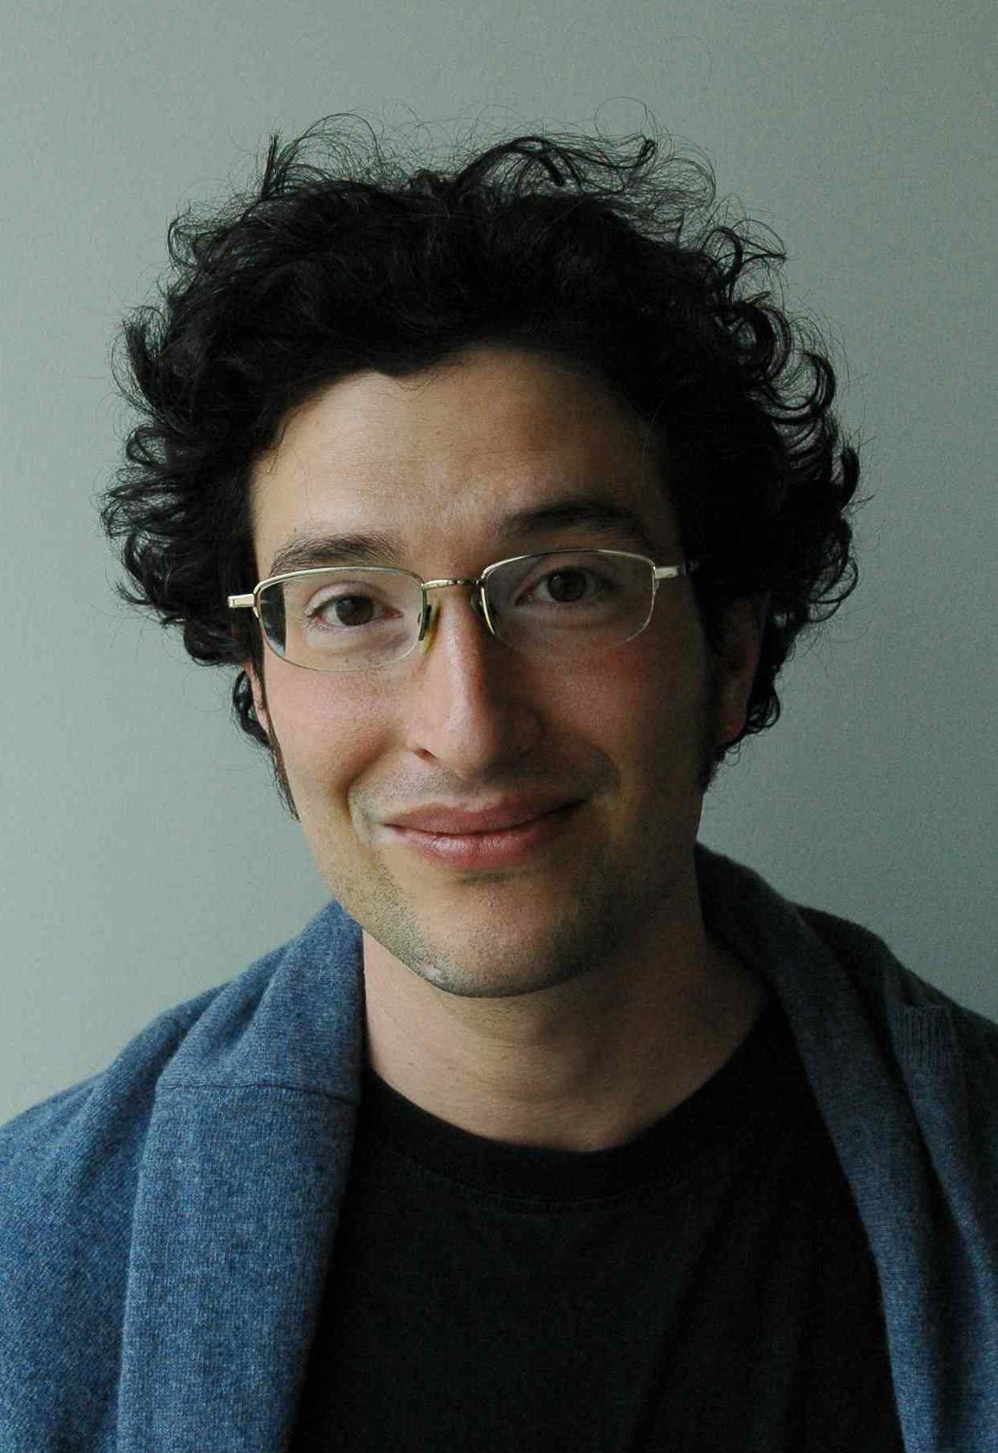
Personal information
First name(s) / Surname(s) |  | Florian Gruber
Address(es) |  | Dreistetten 14, 2753 Markt Piesting, Austria
Telephone(s) |  | +43 1 650 99 44 671
Fax(es) |  | +43 1 495 04 42 40
E-mail |  | gruber@zsi.at
Nationality |  | Austrian
Date of birth |  | 1.12.1973
Gender |  | male
Work experience
Dates |  | 2005- ongoing
Occupation or position held |  | Project Manager
Main activities and responsibilities |  | Overall duty: Management and design of projects in different international programmes (mainly FP7) with the focus on international STI co-operation with a special focus on South and Southeast Asian countries. Scientific analysis of research and innovation systems.  Main tasks:, Workpackage lead “Evaluation, Monitoring and Foresight” at the EU-India ERA NET (New-INDIGO) beginning 2009, Workpackage leader “Analysis” at the Southeast Asian Inco-Net (SEA-EU-NET) beginning 2008; 2009-2010: Steering Board Member for the preparation of the OECD regional innovation review Southeast Asia; From 2005-2007 workpackage leader “Communication and Dissemination” for the Southeast European Era-Net (SEE-ERA.NET). Supporting the launch of STI cooperation calls for Southeast Europe and India. Contribution to project proposals: SEE-ERA.NET enlarged; SEE-ERA.NET PLUS, SEA-EU-NET and SEA-EU-NET II; New-INDIGO;  Special task: Project lead “Internationalisierungsstrategien Österreichischer FTI Stakeholder mit Drittstaaten”; analytical support to Austrian Ministries BMWF, BMWFJ, BMVIT
Name and address of employer |  | Centre for Social Innovation - ZSI, Linke Wienzeile 246, A-1150 Vienna, Austria, Europe
Type of business or sector |  | Independent research institute developing knowledge-based application projects focused on social, ecological and economical sustainable development, European integration processes, scientific infrastructures as well as on efficiency and efficacy of socio-scientific research in the EU Research Area (ERA).
Dates |  | 03.2010 – 11.2010; 03.2013- ongoing
Occupation or position held |  | Head of Unit “Research Policy and Development” at ZSI
Main activities and responsibilities |  | Overall duty: Management of one of three units at the Centre for Social Innovation, comprising 20 researchers and experts dealing with national and international projects in the field of research, innovation and development policy.  Main tasks:  - Internal organisation of the unit: Communication, knowledge management, organisation of regular meetings. Coordination of staff, team building, personnel development, human resource management in cooperation with the general management of ZSI. General reporting on unit level, etc.  - Strategy development: Development and execution of annual business plans and strategies for the unit, communication plan. Risk management, etc.  - Project acquisition: Evaluation of business opportunities, call search, liaison with project partners, development of project proposals, support to other team members in proposal writing, etc.
Name and address of employer |  | Centre for Social Innovation - ZSI, Linke Wienzeile 246, A-1150 Vienna, Austria, Europe
Type of business or sector |  | Independent research institute developing knowledge-based application projects focused on social, ecological and economical sustainable development, European integration processes, scientific infrastructures as well as on efficiency and efficacy of socio-scientific research in the EU Research Area (ERA).
Dates |  | 2004- 2005
Occupation or position held |  | Freelancer
Main activities and responsibilities |  | Support to the study program “Intercultural Competencies”
Name and address of employer |  | Danube University Krems, Department for Intercultural Studies, Krems, Austria
Dates |  | 2002 - 2004
Title of qualification awarded |  | Project Manager and Consultant
Principal subjects/occupational skills covered |  | - Coordinating the TEMPUS project “Managing a Sustainable Network of Student Unions in Bosnia and Herzegovina“; writing of the project proposal “Supporting a Knowledge Network of Student Unions in South East Europe”, establishing a fundraising database, providing information about the EC Framework Programme in relation to Bosnia and Herzegovina, organisation of two „NGO Meetings for Higher Education in Bosnia and Herzegovina“  - Consulting on EC Framework Programme. Responsible for writing the project proposal „A Survey of Post Trauma Research in the Western Balkan Countries“
Name and type of organisation providing education and training |  | 2002-2003: World University Service, Austrian Section, Sarajevo, Bosnia and Herzegovina  2003-2004: World University Service, Austrian Section Graz
Dates |  | 2001 - 2002
Occupation or position held |  | Media coordinator
Main activities and responsibilities |  | Developing and implementing the media strategy for the “3rd World Congress for Psychotherapy” in Vienna. Media relations; organisation of 5 press-conferences
Name and address of employer |  | World Council for Psychotherapy (WCP), Vienna, Austria
Education and training
Dates |  | 1996-2001
Title of qualification awarded |  | Master of Arts (Mag. phil.)
Principal subjects/occupational skills covered |  | Social and Cultural Anthropology
Name and type of organisation providing education and training |  | University of Vienna
Personal skills and competences
Mother tongue(s) |  | German
Other language(s)
Self-assessment |  |  | Understanding |  |  |  |  | Speaking |  |  |  |  | Writing
European level (*) |  |  | Listening |  | Reading |  |  | Spoken interaction |  | Spoken production
English |  |  | C2 | excellent | C2 | excellent |  | C2 | excellent | C2 |  | excellent | C2 | excellent
French |  |  | B1 | fair | B1 | fair |  | B1 | fair | B1 |  | fair | A2 | sufficient
Bosnian/Croatian/Serbian |  |  | A2 | sufficient | A2 | sufficient |  | A2 | sufficient | A2 |  | sufficient | A1 | basic
 |  | (*) Common European Framework of Reference for Languages
Social skills and competences |  | - Intercultural competencies  - team player and networker  - proven ability to manage and lead teams  - able to structure processes and communication flows  - negotiations in political contexts  - conflict management
Organisational skills and competences |  | - Project management skills  - Personnel development
Technical skills and competences |  | - Quantitative and qualitative methodologies in the social sciences  - Evaluation and monitoring methodologies  - Financial and administrative management  - Organisation of workshops and large-scale conferences
Computer skills and competences |  | most popular word processing-, graphical-, statistical-, and calculation-programmes for DOS/Windows as well as DTP skills (QuarkXpress, Photoshop)
Artistic skills and competences |  | Percussionist (drums, mrdangam, tavil, kanjira), Jaw Harpist, Blacksmith, Bowyer
Other skills and competences |  | Participation at prehistoric excavations in Austria, voluntary work at the Department for Anthropology of the Museum of Natural History Vienna and the Museum of Ethnology in Vienna; 6 months of anthropological fieldwork in Tamil Nadu, India; briefly working for Greenpeace; studying the Asian martial art Jiu Jitsu as a youngster (green belt).  In my spare time I build reproductions of bows and arrows from various cultures and historical times; I like to go to the mountains. Apart from this I like to cook and read.
Driving licence |  | Category B – cars
Additional information
Annexes |  | Publications; Presentations; Organisation of Conferences, Seminars, Workshops; Projects

Annex A: Publications

2012 “Aussenaktivitäten und strategische Überlegungen zu Internationalisierung (EU-Drittländer) in Forschung, Technologie und Innovation (FTI)”; Bestandsaufnahme österreichischer FTI Stakeholder; Florian Gruber, Cosima Blasy, Klaus Schuch, Ruth Müller, Lisa Sigl, Camen Heidenwolf; prepared for Austrian Ministry for Science and Research, Ministry for Transport, Innovation and Technology, Ministry for Economy, Family and Youth

2011 “Towards Professionalising ‘International S&T Cooperation Foresight’: Epistemological and Methodological Challenges and How to Overcome Them” Alexander Degelsegger, Florian Gruber, Isabella Wagner, EFP Brief,

2011 “Co-Publication Map: S&T Cooperation between Europe and India” by Alexander Degelsegger, Florian Gruber. New INDIGO project, Vienna, 2011

2011 “Scientific cooperation between Southeast Asia and Europe in 2020. Driving factors as assessed by scientists and policy-makers” by Alexander Degelsegger, Florian Gruber, in: : Spotlight on: Science and Technology Cooperation between Southeast Asia and Europe, Degelsegger, Blasy (ed.), Vienna, 2011

2011 “Southeast Asia’s international S&T cooperation policy” by Margot Schüller, Rudie Trienes, Alexander
Degelsegger, Ludwig Kammesheidt, Florian Gruber, in: Spotlight on: Science and Technology Cooperation between Southeast Asia and Europe, Degelsegger, Blasy (ed.), Vienna, 2011

2011 Degelsegger, Alexander& Gruber, Florian: Scientific cooperation between Southeast Asia and Europe in 2020. Driving factors as assessed by scientists and policy-makers, SEA-EU-NET Deliverable 4.2 to the European Commission, online at http://www.sea-eu.net/object/document/2469.html, last accessed: 24 July 2011

2011 Blasy, Cosima, Gruber Florian: “Zur Messbarkeit Sozialer Innovationen”, in: Pendeln zwischen Wissenschaft und Praxis, Hochgerner, Josef (ed.), IT Verlag 2011: Münster – Berlin – Wien – Zürich – London

2010 Gruber, Florian & Degelsegger, Alexander: S&T Cooperation Foresight Europe – Southeast Asia, in: Форсайт (Foresight), 4(3), 56-68.

2010 “Policy recommendations for enhancing Science and Technology cooperation between the European Union and Southeast Asia” authors: Rudie Trienes, Florian Gruber, Dreistetten, March 2010

2009 “Spotlight on: Excellent Researchers from Southeast Asia; Results of a SEA-EU-NET Mapping Study”, authors: F. Gruber, A. Degelsegger, Vienna, October 2009

2008 “International Science and Technology Cooperation Policies of South East Asian Countries: Consultation Paper Prepared for the EU Commission on the Occasion of the First Bi-Regional S&T Policy Dialogue, EU-ASEAN, 19-20 November 2008, Paris” authors: M.Schüller, F. Gruber, R. Trienes, D. Shim; Hamburg, Vienna and Amsterdam; 2008

2007 „White Paper on Gaps, Overlaps, and Opportunities in View of the Extension of Bilateral RTD Programmes and Initiatives towards Multilateral Approaches“. authors: Rost, Gruber et al. In: Transition Studies Review. Vol 14 Nr.2, Springer: Wien, New York

2005 National RTD programmes for Southeast Europe: A Comparative Summary Report, Hinsenkamp, Gruber et al, Centre for Social Innovation, Zagreb

2003 “The 6th Framework Program and the Western Balkan Countries”, Broschure, WUS-Austria, Sarajevo

2003 „Förderung der höheren Bildung in Bosnien und Herzegowina“. In: FriedensDienst, Nr.4 Österreichische Friedensdienste, Graz, 2003

2001 „Widerstand: Vom Wetzen der Waffen der Schwachen in der Kultur- und Sozialanthropologie“; Diploma thesis, (unpublished)

Annex B: Presentations (selection)

2011 “New INDIGO Foresight – process and outcomes”, 1.12.2011, Vienna, Austria, Strategic Forum for International Cooperation

2010 “Policy recommendations for enhancing S&T relations”, 05.2010, Vientiane, Lao PDR, ASEAN-COST meeting

2009 “Scenario for 2020 S&T multilateral cooperation between Europe and Southeast Asia – first results” 12.11.2010, Bogor, Indonesia, SEA-EU-NET Bi-Regional Science and Technology Policy Dialoge, EU-ASEAN, Bogor, Indonesia

2009 “Spotlight on: Excellent Researchers from Southeast Asia”, November 11, 2009; Bogor, Indonesia. SEA-EU-NET Bi-Regional Science and Technology Policy Dialoge, EU-ASEAN, Bogor, Indonesia

2008 “International Science and Technology Cooperation Policies of South East Asian Countries“,First Bi-Regional Science and Technology Policy Dialogue,
EU-ASEAN, 19-20 November Paris

2008 Series of presentations to high-level S&T stakeholders in Southeast Asia during the SEA-EU-NET Fact Finding Mission, 19.08.08 – 6.09.08

2007 “SEA-EU-NET: Facilitating the Bi-Regional EU-ASEAN S&T Dialogue”; Südostasienwissenschaften Konferenz, Vienna, 15.06.2007

2007 “Regional Programme for Cooperation with Southeast Europe”, SEE Science Days, Graz, Austria, 18.10.2007

2007 “New opportunities for multilateral RTD cooperation”, WU Vienna, Austria, 06.07.2007

2007 “The 7th Framework Programme and opportunities for the Western Balkan countries in ICT”, IS2WEB workshop, Belgrade, Serbia, 02.07.2007

2006 “Creating Divides for Peace: one aspect from an analysis of peace-building projects in Bosnia and Herzegovina”, EASA conference “Europe and the World”, Bristol, 18 – 21.09.2006

2006 “Networking with Southeast Europe - SEE-ERA.NET” at: "Integration of EU Enlargement Countries to the European Research Area: Participation in EU Seventh Framework Programme (FP7) Workshop", Istanbul, Turkey, 06.12.2006

2006 “SEE-ERA.NET initiatives (www.see-era.net), Pilot Joint Call - 2006/2007” at "The New State Aid for RTDI Framework" – IGLO open session, Brussels, 05.12.2006

Annex C: Organisation of Conferences, Seminars, Workshops (excerpt)

2011 Trainer at SOQUA (Sozialwissenschaftliche Berufsqualifizierung) Module 4.1 “Europäische
Forschungskooperation“, September 22-23, Vienna,
2010 Workshop-Lead “F&E-Internationalisierungsindikatoren”, July 26-17, Vienna, SOQUA Summer School

2010 Informal foresight talks at ASEAN-COST meeting in Vientiane, Lao PDR

2009 SEA-EU-NET foresight workshop in Bogor, Indonesia, 11.2009

2009 SEA-EU-NET Methodology Workshop, 6.-7-04.2009, Vienna, Austria

2008 Consultation Paper Workshop, 2.-3.10.08; Vienna, Austria

2007 Quality Assurance Workshop, 22. - 23. 10. 2007, Sofia, Bulgaria

2006 SEE-ERA.NET National Contact Point Training, Seminar, 23. - 24. 11. 2006, Rhodes,
Greece

2006 Software Integration Workshop, 13.03.2006, Vienna, Austria

2005 “New approaches for RTD co-operation in the European Research Area: Regional and
European wide co-operation with Southeast Europe”, SEE regional conference, Zagreb,
Croatia, 15.-16.12.2005

2003 2 NGO Meetings for Higher Education in Bosnia and Herzegovina; Sarajevo, Bosnia and
Herzegovina, 03.05.2003; 17.10.2003

2002 “3rd World Congress for Psychotherapy”; Vienna, Austria, 10.-15.06.2002

Annex D: Projects

2012 “Internationalisierungsstrategien Österreichischer FTI Stakeholder mit Drittstaaten (Internationalisation Strategies of Austrian RTDI Stakeholder with Third Countries)”; analytical support to Austrian Ministries BMWF, BMWFJ, BMVIT

2009 Initiative for the Development and Integration of Indian and European Research – New INDIGO (South Asian ERA-Net; client: European Commission)

2007 Facilitating the Bi-Regional EU-ASEAN Science and Technology Dialogue – SEA-EU-NET (Southeast Asian INCO-Net; client: European Commission)

2006-2008 see-science-eu: Information Office for the Steering Platform on Research fro the Western Balkan Countries (client: European Commission)

2005-2008 Southeast European Era-Net – SEE-ERA.NET (client: European Commission, bm:bwk)

2003 Academic Information Network for South East Europe – AINSEE (client: WUS-Austria)

2002-2003 Managing a Sustainable Network of Student Unions in Bosnia and Herzegovina (client: TEMPUS office)

