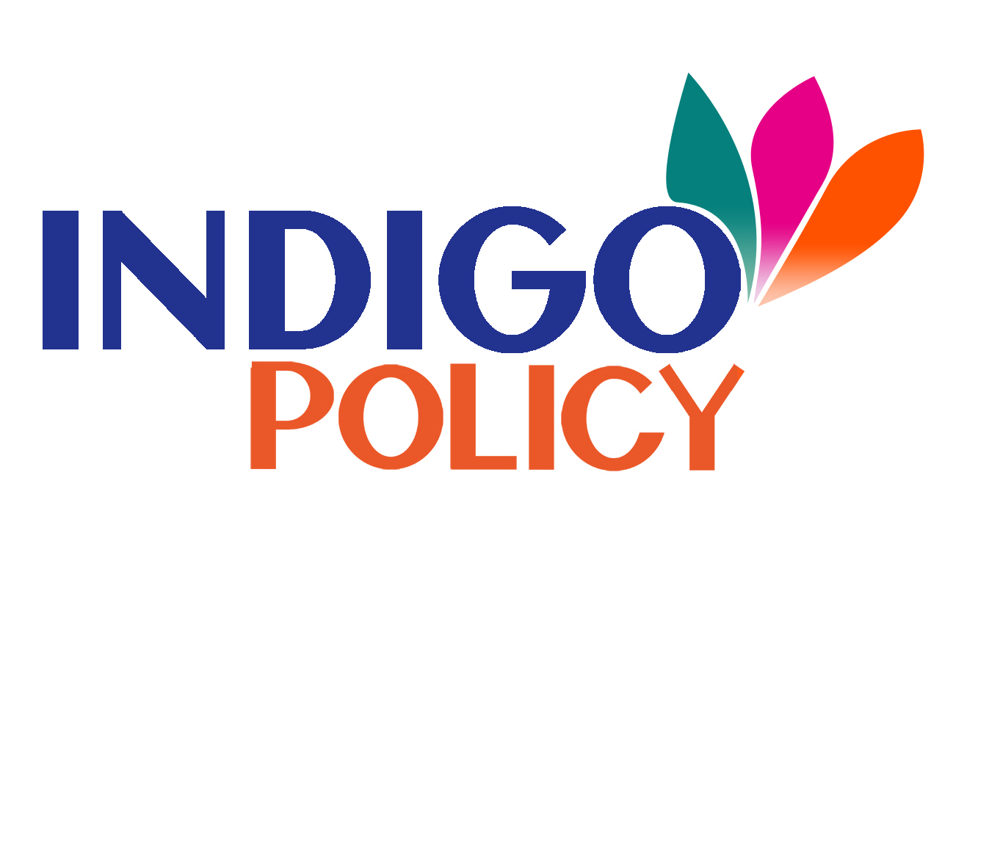

Application Form: INDIGO POLICY linking programme on biotechnology in the field of health
- Project information
Detailed subject area (max 200 characters)
Keywords
Proposal runtime
- General data
Organization : Coordinator
Organization Name
Organization type
Institute/ Department
Address
Country
Website
Name of coordinator
Tel of coordinator
e-mail of coordinator
Description of the organization (max. 500 characters)
Organization: Partner 1
Organization Name
Organization type
Institute/Department
Address
Country
Website
Name of contact person
Tel of contact person
e-mail of contact person
Description of the organization (max. 500 characters)
Organization: Partner 2
Organization Name
Organization type
Institute/Department
Address
Country
Website
Name of contact person
Tel of contact person
e-mail of contact person
Description of the organization (max. 500 characters)
Organization: Partner 3 (optional)
Organization Name
Organization type
Institute/Department
Address
Country
Website
Name of contact person
Tel of contact person
e-mail of contact person
Description of the organization (max. 500 characters)
Organization: Partner 4 (optional)
Organization Name
Organization type
Institute/Department
Address
Country | □ Member State □ Associated State
Website
Name of contact person
Tel of contact person
e-mail of contact person
Description of the organization (max. 500 characters)

- Management Structure
Describe the organizational structure and the decision making(including a list of milestones (max 500 characters)
Framework of the cooperation, duration, scientific project
How do the members complement one other? In what way each of them contribute to the project (max 500 characters)

- Proposal for a multilateral virtual lab
Bilateral cooperation historical background (max 1,000 characters)
Framework of the cooperation, duration, scientific project
Main aim of the network (max 300 characters)
Short Abstract (max 1000 characters)
- Documents required for the application
- Information on each involved institution and the researchers (including CV) – 1 page max. per institution
- Description of the existing bilateral cooperation /Publication/patents already in common
- Scientific Program (3-5 pages)
- Provisional project budget for the phase 1 (January 2015 – July 2016) and for the phase 2, including the provisional source of funding (2016-2018)
- Program of planned activities with name of travelers, institutions and schedule dates – 1 page max.
The full application has to be sent electronically to linkingprogramme@indigoprojects.eu before September 29th.

