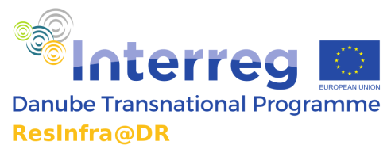



**PRESS INFORMATION**

**ResInfra@DR Know-how exchange forum on 22-23 May 2019 in Bratislava**Focusing on research infrastructures mutual activities in the Danube macro-region

*Bratislava, Vienna* – ResInfra@DR project’s mission is to improve framework conditions for research infrastructures (RIs) and innovation in the Danube macro-region. One key objective of the project is to contribute to the efforts for establishing new RIs and upgrading the existing ones by strengthening both policy-making and managerial capacities in the Danube macro-region.

Throughout the last year the ResInfra@DR project has offered support to interested research infrastructures in Danube region concerned with management challenges during their regular operations or specific phases of their establishment. The **ResInfra@DR Know-how exchange forum** provides an excellent venue for stakeholders (including final recipients of support such as involved research entities and infrastructures) to reflect on the current challenges of the initiatives and the proposed recommendations. In addition, a reflection of the process itself should reveal the potential of similar mutual support actions in the Danube macro-region, and how far similar actions should be included in a joint action plan. In order to provide ground for reflection, the organisers have invited currently developing RIs and already successful initiatives to allow a wider sharing of experiences.

**Agenda and registration**  
The event is open to RI experts and stakeholders from media. In case of interest, please contact Ms **Anna Krivjanska**, Centrum vedecko-technickych informacii SR (CVTI SR) to gain further details and the agenda – best by 19th of May 2019: [anna.krivjanska@cvtisr.sk](mailto:anna.krivjanska@cvtisr.sk)

Learn more about the [Resinfra@DR project](http://www.interreg-danube.eu/approved-projects/resinfra-dr/) and the Interreg Danube Transnational [Programme…](http://www.interreg-danube.eu/about-dtp/programme-presentation)

**International press contact**Ms Pamela Bartar, Centre for Social Innovation (ZSI), Vienna: [bartar@zsi.at](mailto:bartar@zsi.at) or office@resinfradr.eu