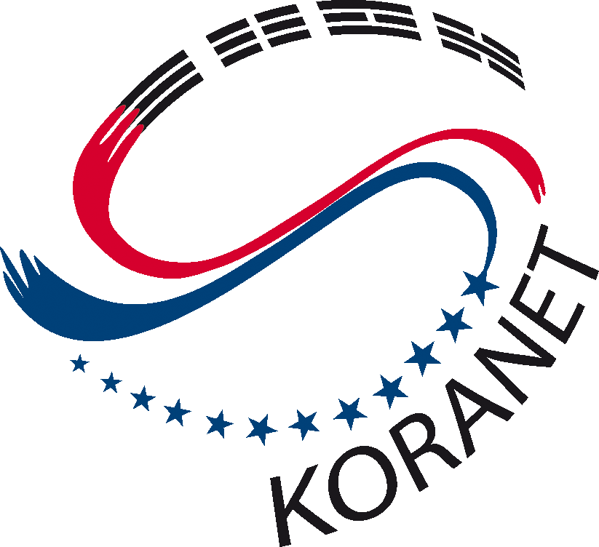
KORANET Workshop on
Green ICT Solutions
20th of October 2009
Istanbul, Turkey

AGENDA

Venue:
The Marmara Hotel
Opera Room (Verdi-Mozart-Wagner)
Istanbul, Turkey

Organizers:

Ms. Gülsün ERYILMAZ, TÜBİTAK
koranet@tubitak.gov.tr Tel: 0090 312 4685300/2808

THE CONTEXT
There has been a great increase on the level of concern regarding climate change and environmental sustainability issues trough out all technology and business sectors. Businesses are under increasing pressure from customers, shareholders and proposed legislative changes to improve their environmental image. As well as the environmental impact of Information Communication Technology (ICT), Green ICT, has become hot topic by academia, media and government.
The EU is generally considered to be in front in the use of “ICT to help other industries reduce their carbon emissions”. The EU aims to use ICT to monitor, optimise and reduce the energy consumption in construction, heating, cooling and lighting of buildings some 40 per cent of the energy consumed in Europe today. It is obvious that ICTs will be essential to efforts aimed at saving vast amounts of energy.
Therefore the need for GREEN ICT is obvious and new sector groups are springing up constantly. Energy reduction through better equipment engineering, better data centre design, and better work management is the easy answer. It is clear to everyone that to reduce the carbon footprint in many cases cuts costs.
This one-day workshop on GREEN ICT is organised in the frame of KORANET, a four-year project financed by the 7th Framework Programme on Research and Development of the EU. The project aims at enhancing the S&T cooperation between European countries and Korea.
Idealist e-Challenge Pre-conference Brokerage (An Information and Brokerage event in the field of Information and Communication Technologies of the 7th Framework Programme) will take place in The Marmara Hotel on the same day with the Green ICT Workshop. Hence this workshop will also facilitate networking with the participants of the Idealist Brokerage Event and eChallenges e-2009 Conference.

OBJECTIVES AND EXPECTED RESULTS
Review best practices in Korea’s international cooperation activities in green ICT field.
Examine the current novel approaches to environmentally friendly ICT solutions
Evaluate the international opportunities to raise awareness on environmental impact of ICT
Provide networking with the participants of eChallenges e-2009 Conference working on diverse areas of ICT
The KORANET workshop will contribute to finding ways to reduce carbon foot print and eventually help to prevent climate change.

PARTICIPANT PROFILE
Researchers, Professional associates, ICT academics and professors

GREEN ICT SOLUTIONS

08:30 – 09:00 | Registration
09:00 – 09:50 | Welcome and introduction  - Marion STEINBERGER, KORANET Project Coordinator  - Oguz YAPAR, FP7 Deputy National Coordinator, TUBITAK  - Keynote speech by an expert and/or officer for ICT (from EC)*
09:50 – 10:50 | Moderator, Dr. Ahmet KAPLAN, Vice-President, TÜRKSAT  Prof. Soo-Won KIM , College of Engineering, Korea University, Korea  History of Semiconductor Technology and Its Future  Dr. Burcu AKATA KURC, Middle East Technical University, Turkey  Potential Cooperation Schemes With Korea Via FP7
10:50 – 11:20 | Coffee break
11:20 – 12:30 | Moderator, Dr. Ahmet KAPLAN, Vice-President, TÜRKSAT  Jussi AHOLA – Technical Research Centre of Finland  Green ICT @ VTT; Empowering people  Prof. Sung-Wun KIM, College of Engineering, Pukyong University, Korea  Green Network
12:30 – 12:45 | Summary (Prof. Levent GUVENC, Istanbul Technical University)
12:45 – 14:00 | Lunch (together with Ideal-IST participants)
14:00 – 16:00 | Moderator, Prof. Levent GUVENC  Dr. Sungwon LEE, Kyunghee University, Korea  & Dr. Ilwoo LEE, Electronics and Telecommunications Research Institute (ETRI), Korea  Energy Prosumer Solution in the Smart Grid  Joon Won LEE, Andong National University, Korea  Green ICT Standardisation in Korea  Bert VAN WERKHOVEN, Ideal-ist Partner, SenterNovem  (Some participants will attend to IDEAL-IST Brokerage Event)
16:00- 16:30 | Closing words (Prof. Levent GUVENC)
16:30- 17:00  17:00- 18:30 | Coffee break  Networking Reception (together with Ideal-IST participants)

