Draft
(as of October 24 2008)

CAN “UNITED NATIONS” BE TAUGHT?
-
A Central, East and Southeast European Regional Colloquium on
Innovative Techniques for Teaching about the United Nations System

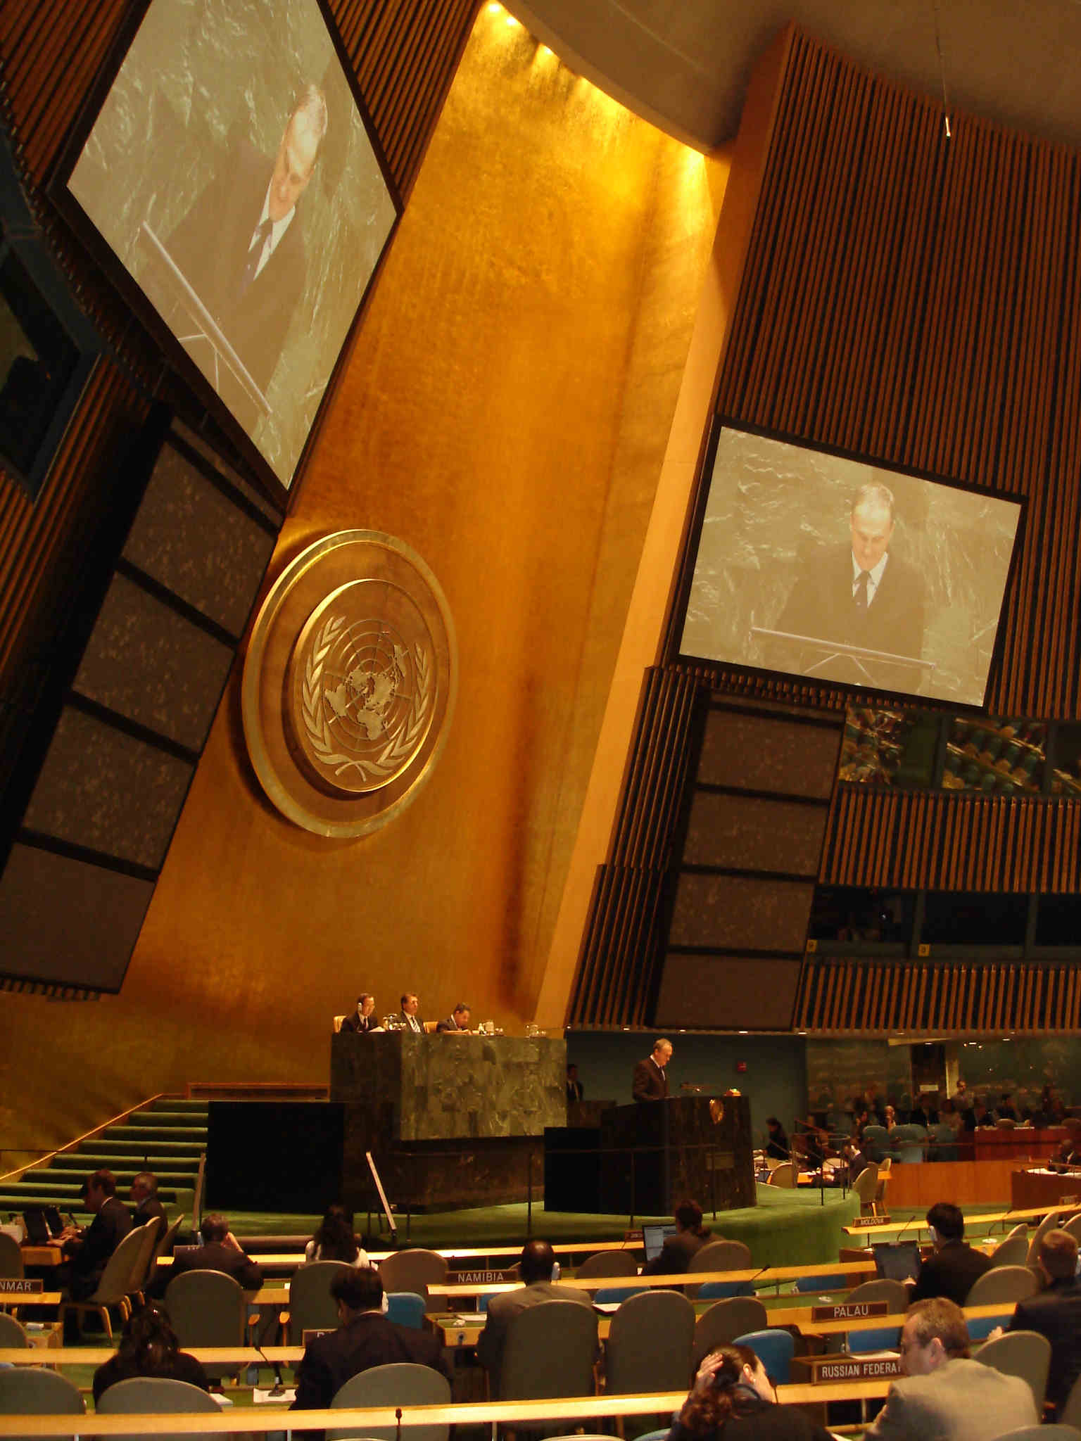

Organisers: - Academic Council on the United Nations System (ACUNS)
- Diplomatic Academy of Vienna
- Austrian Science and Research Liaison Office (ASO) Ljubljana
- Central and Eastern European International Studies Association CEEISA

in cooperation with: - United Nations Association of Austria (UNA-Austria)
- Academic Forum on Foreign Affairs, Vienna (AFA)
- Permanent Mission of Austria to the United Nations Office Vienna
- International Institute of Applied Systems Analysis IIASA Laxenburg
- Austrian Institute for International Affairs (OIIP)
- Austrian National Commission for UNESCO
- United Nations Information Service, Vienna (UNIS)
- European Training Center for Human Rights, Graz
- Moscow State Institute of International Relations (to be confirmed)
- United Nations Studies Association
- University of Graz Institute of International Law
- University of Vienna, Institutes of Criminal Law and
International Law
- World Federation of United Nations Associations

Date: 22nd of November 2008, 11:00 - 17:00

Venue: Diplomatic Academy, Vienna, Austria
Rationale and Objectives of the Colloquium:

As Global Issues become more and more topical on the political agenda of any country in the world and as the United Nations system is within the existing global system of international relations the central institutional framework for global governance responses to global challenges (like e.g. the ongoing UNFCCC climate change negotiations as the process to coordinate globally climate change mitigation and adaptation measures or the Millennium Development Goals as a shared global vision for development agreed upon in the UN Millennium Declaration, etc.), it is important that there are developed appropriate human capacities in each country with the knowledge on the functioning of the UN system in order to enable all relevant stakeholders to contribute to the success of efforts of the international community to address global challenges and in order to enable countries to defend their interests according to the rules of play.

As the issues confronting the world have become more complicated, new teaching techniques are required to convey the complexity of the problems and the diversity of possible outcomes. In this context higher/tertiary education plays a key role and obviously there are huge potentials for mutual learning in addressing these human resources development issues in an international/regional setting.

But how can United Nations subjects best be addressed at Universities? There are emerging interesting new approaches of teaching UN related subjects through case teaching, structured debates, simulations, role play, experiential learning, using film and new media, use of information technology, google maps and electronic resources (available from UN agencies) and wiki-portals. Experiences will be exchanged about inter-active teaching techniques with the hope that a network of teachers and a compendium of effective activities be established.

Therefore, with this colloquium the organizers want to
- better understand who is doing what in the field of United Nations studies in Central, Eastern and Southeastern Europe
- identify and discuss innovative initiatives on teaching about the UN system
- contribute to regional cooperation

Expected concrete outcomes of the colloquium are
- a compendium/handbook on “Innovative Techniques/Approaches in Teaching about the UN System” that should be published in the “favorita papers” book series of Diplomatic Academy in Vienna
- project initiatives for regional cooperation in UN studies / teacher training and development of a website
Draft programme

11:00 Session I Welcome
Chair: Michael Platzer (Academic Council on the United Nations System Liaison Officer in Vienna)

- Jirí Gruša (Director of the Diplomatic Academy of Vienna)
- Helmut Böck, Permanent Representative of Austria to the United Nations (Vienna)
- Tour de Table (each participant introduces him- or herself by name and institutional affiliation as well as with the title of his/her intervention in sessions III and IV (each participant is invited to bring to the colloquium a 2 page information on innovative UN related teaching initiatives (implemented and planned ones) he/she is involved in; these contributions will be put together with some analytical articles in a compendium/handbook and published in a special edition of the “Favorita Papers” book series of Diplomatic Academy in Vienna)

- Keynote: Thomas Stelzer, Assistant Secretary-General for Policy Coordination and Inter Agency Affairs, United Nations, New York
How can the academic world support the work of the UN system?

11:45 Session II Thematic Introduction and Brief Status Quo Analysis regarding UN Teaching in Tertiary Education in CEE/SEE and
Chair: Gerhard Reiweger (Deputy Director of the Diplomatic Academy of Vienna)

Thematic Introduction - Innovative Teaching and Learning about the UN System
– Patricia Goff, Executive director, Academic Council on the United Nations System, ACUNS

Brief Status-quo Analysis for CEE/SEE region
Introductory statements:
- Zlatko Šabič, Faculty of Social Sciences of the University of Ljubljana, president of Central and East European International Studies Association (report on WISC 2008 conference, CEEISA membership etc.) &
- Marina M. Lebedeva Moscow State Institute of International Relations (trends of regional (research and educational) cooperation on UN issues in Eastern Europe) (to be confirmed)
- Axel Wüstenhagen, Results of an Inventory of UN studies in Austria

Discussion

13: 00 – 14.00 Lunch hosted by H. E. Mr. Helmut Böck, Permanent Representative of Austria to the United Nations (Vienna)

14:00 Session III: Simulations, Role Play, Structured Debates, Case Studies, etc.
Chair:

Short interventions (5 min each)
- Matthias Ketteman- University of Graz - Using Structured Debates
- Helmut Prantner - University of Vienna - Historical Model UNs
- Stefan Schuman - University of Viennna - Experiental/ Service Learning
- Ewald Rametsteiner, International Institute of Applied Systems Analysis – Processes of International Negotiation
- Ingfrid Schütz-Müller- University of Vienna - Excursions to UN Headquarters
- other participants (advance notification of presentation/intervention would be welcome)

15:30 Session IV: Technology Enhanced Learning about the United Nations System – Active Learning Techniques etc.
Chair: Hanspeter Neuhold (Diplomatic Academy of Vienna)

E-Learning, UN digital platforms/ databases, Good Websites, On-Line Textbooks, Classroom Blogs, Film Discussions,

- Karin Bruckmüller - University of Vienna - E-learning
- Henrike Paepke, United Nations Studies Association, UN Studies wiki Portal
- Alexander Siedschlag, Center for European Security Studies - WWEDU World Wide Education, Report on the word wide real-virtual colloquium “The United Nations and the information age – Education for the next Generation of ‘the Peoples of the United Nations’”, November 2007, Wels/Austria
- N.N., United Nations Information Service, Vienna (UNIS) - computer based materials useful for education or training on the United Nations provided by Vienna based UN entities
- Slawomir Redo, UNODC, Justice & Integrity Unit, Division for Operations) The UNODC computer-based tools for the international criminal justice education
- Dietmar Lampert, Centre for Social Innovation, Vienna: presentation of the broadband videoconferencing tool “GLOBAL - Global Linkage Over BroadbAnd Links” http://global-project.eu/
- other partcipants (advance notification of presentation/intervention welcome)

16.30 Session V: CEE/SEE regional cooperation on UN Studies and Teaching: The Way Ahead?!
Chair: Miroslav Polzer, ASO Ljubljana
- Shared interests?
- Needs assessment regarding capacity building in SEE/CEE related to UNFCCC Climate Change negotiations in Poznan and Copenhagen
- Existing funding programmes for regional initiatives?
- Possibilities for funding within (Austrian) Official Development assistance programmes?
- Next steps and follow-ups?

17.00 Closing
Expected number of participants: 30

Travel grants:

The Austrian Science and Research Liaison office Ljubljana will offer travel grants for up to 12 participants from South Eastern European countries (for details please contact Mr. Miroslav Polzer polzer@zsi.at, www.aso.zsi.at)

Contact for organizational matters:

janclaudius.bujak@da-vienna.ac.at

