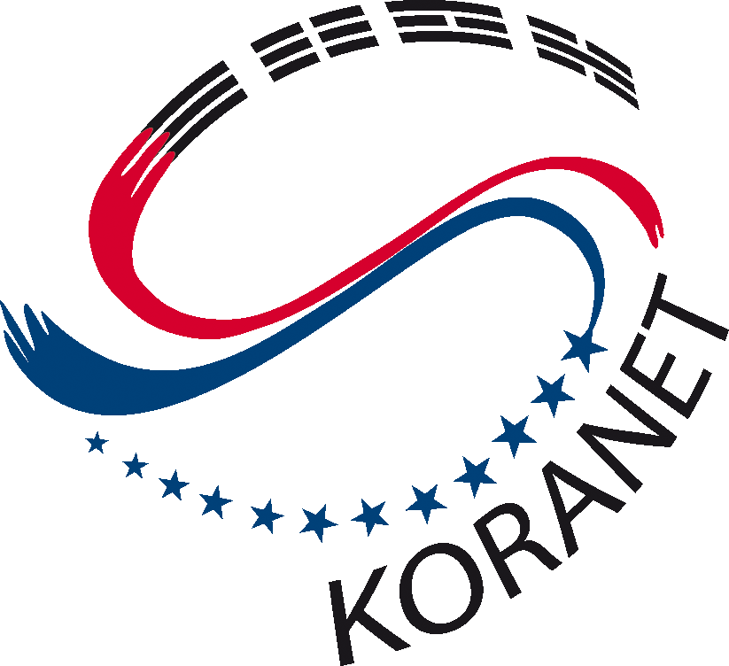

Korea - EU S&T Conference
on Nanotechnology

19 October 2011
Seoul/Korea

REGISTRATION FORM

- PERSONAL DETAILS
Family name:
Other names:
Title: | Mr Ms Dr Prof
Male | Female
Nationality:

- CONTACT INFORMATION
Job title:
Organisation:
Address:
Town or city:
Post code:
Country:
Telephone:
E-mail:
Web address:

Please return this form to Mikko Sallinen (Mikko.Sallinen@vtt.fi) and Jawon Choi (choi_jawon@nrf.re.kr) by 19th September 2011.

